https://thefoxmagazine.com/travel/grand-velas-riviera-nayarit-maintains-itself-regions-leading-luxe-all-inclusive/
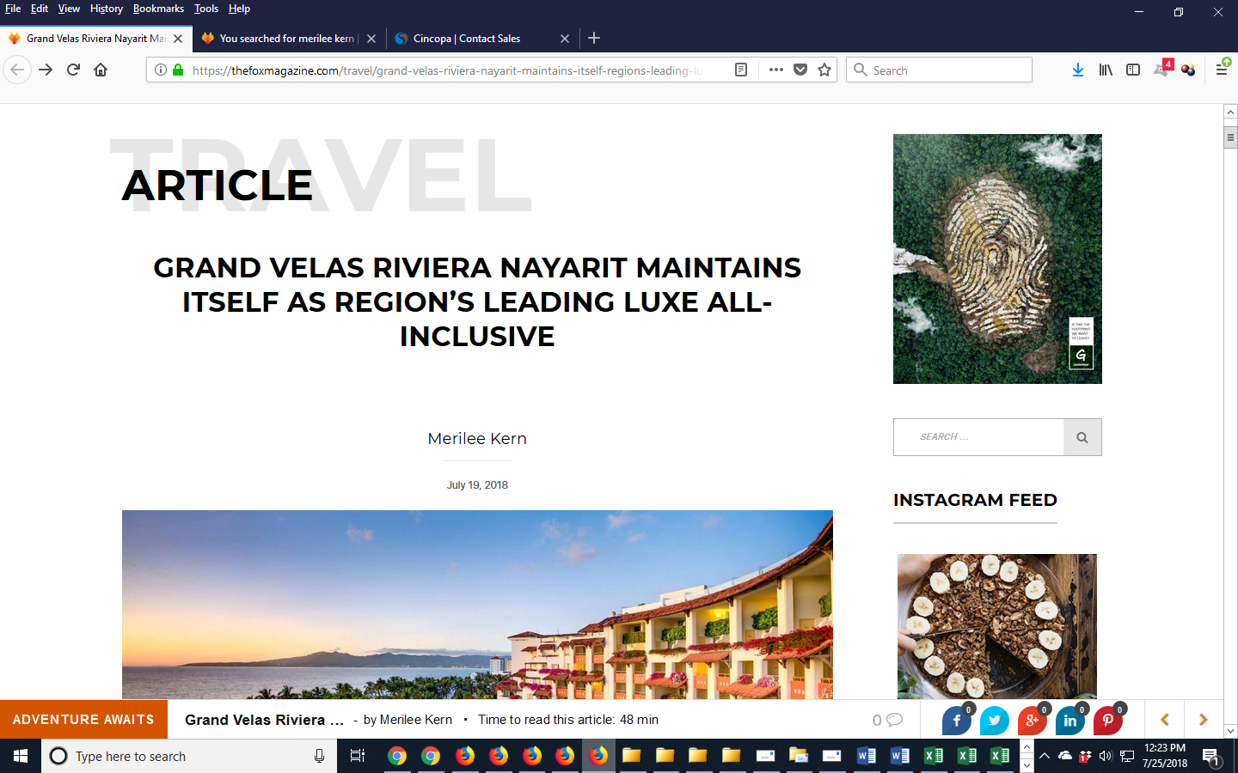

https://thefoxmagazine.com/technology/17-savvy-summer-solutions/

https://thefoxmagazine.com/travel/rhythms-night-dinner-show/
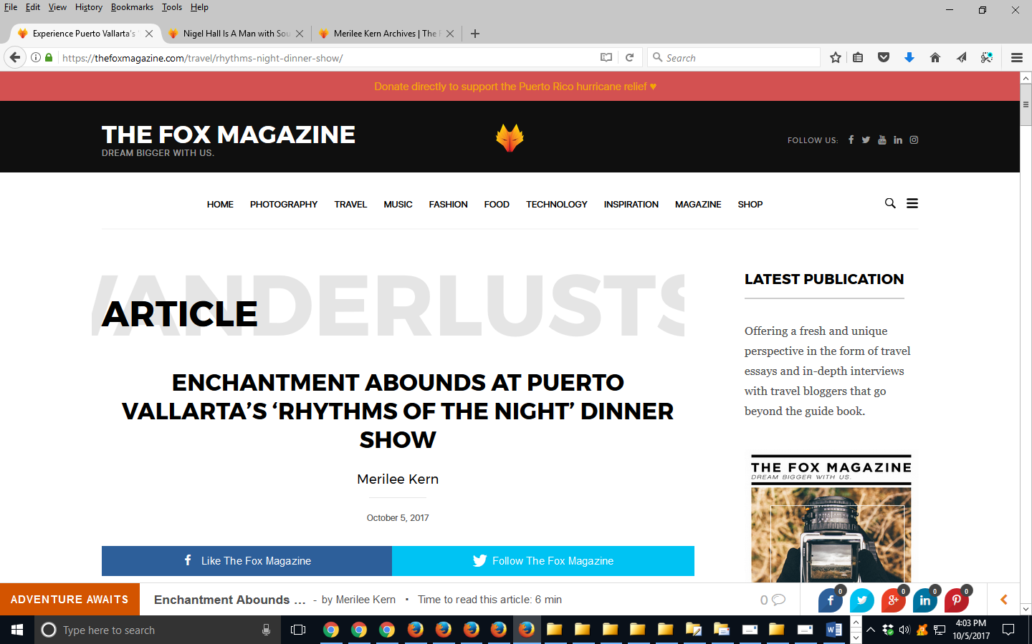

https://thefoxmagazine.com/travel/5-amazing-west-mexico-vacation-destinations
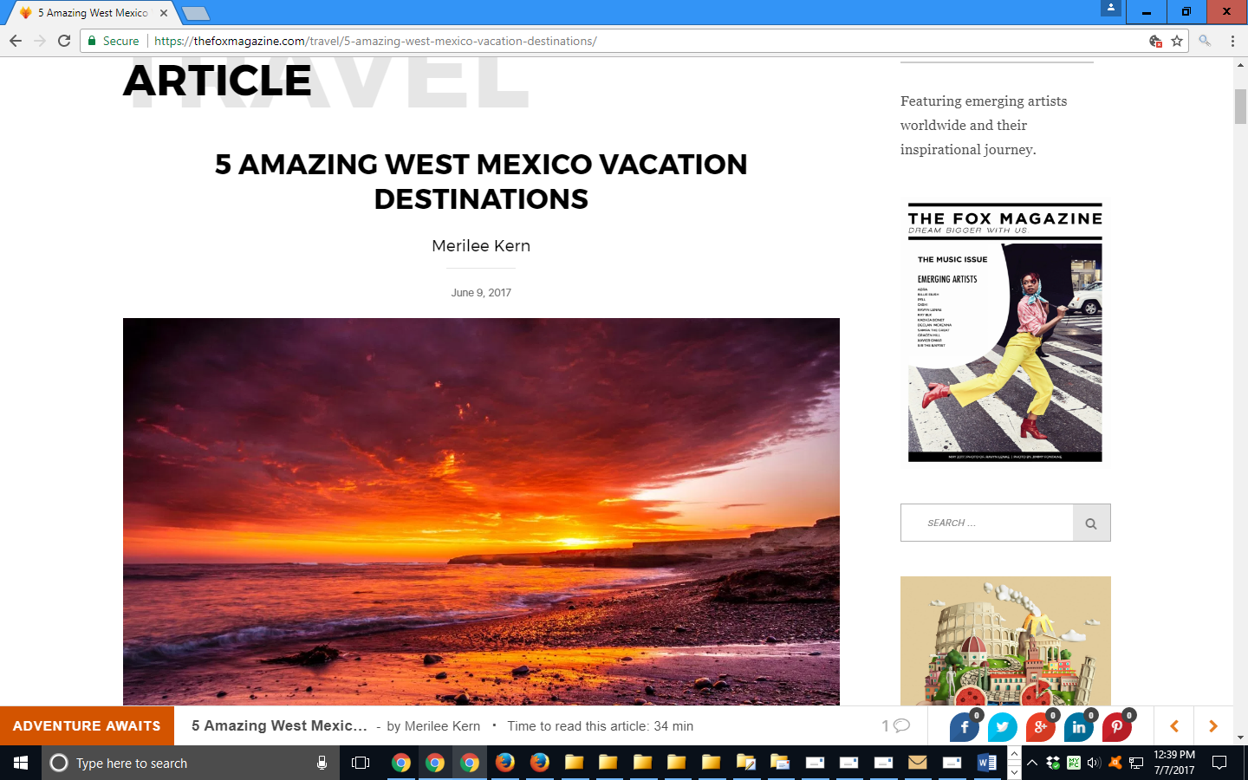

https://thefoxmagazine.com/?s=merilee+kern

