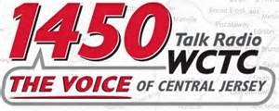

WCTC-AM "Jersey Central" Show with Bert Baron, New Jersey. WCTC-AM broadcasts throughout the central New Jersey area at 1450 AM. WCTC-AM's slogan is "The Voice of Central New Jersey." More show info here.

Luxe List Interviews (click to listen):

October 2016: Tech-Driven Wellness Innovations
- http://bit.ly/2eAR4MT

December 2016: Holiday Gift Ideas
- https://youtu.be/teriB-nuCIc
- http://bit.ly/2gKhhOM
- http://bit.ly/2hMXKuH

